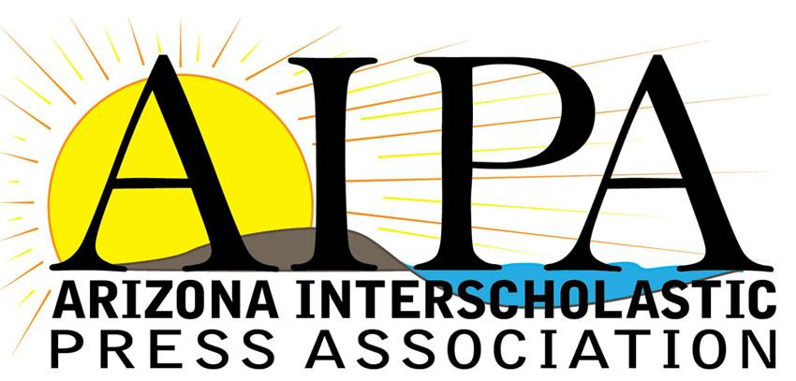

Certificate of Attendance

__________________________________________
Name

__________________________________________
School

Attended the

AIPA Fall Convention

On Tuesday, October 29, 2019

for a total of 5 hours

Melanie Allen

AIPA President

