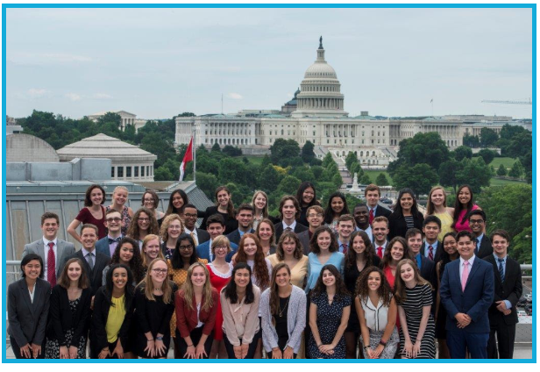
Interested in a career in journalism? Passionate about the First Amendment? Here is an opportunity to attend a prestigious high school journalism conference in our nation’s capital next summer.
Each year, one high school junior from every state and the District of Columbia is selected to attend the (all-expenses-paid) Al Neuharth Free Spirit and Journalism Conference at the Newseum in Washington, D.C. Conference dates for 2019 are June 14-20.

Sponsored by the Freedom Forum Institute in honor of the late Al Neuharth, founder of USA TODAY and the Newseum, the goal of the program is to encourage free-spirited students to pursue a career in journalism and to emphasize the importance of the First Amendment in a democracy. Each student is awarded a $1,000 scholarship to the college of his/her choice.
Additional information about the program -- and its online application -- can be found at www.freespirit.org.

The deadline to apply is February 1, 2019.

Questions? Contact Karen Catone at kcatone@freedomforum.org or 202-292-6271.

